**Software Development 2**

**Unit 7 Practical**

1. Open the Visual Studio solution Unit7.sln and examine the console project “Poly1”, which contains 3 classes Vehicle, Truck and Car as follows:

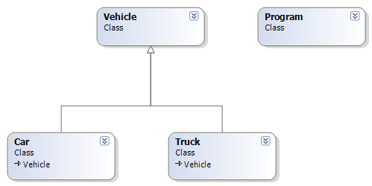

1. In the Main() function within the Program class add code to create a List that can store objects of type Car, Truck or Vehicle.
2. In Main() add code to create examples of Vehicle, Car and Truck objects to your list.
3. In Main() add code to call the print() method of each object that you have created and stored, you should see a list of Vehicle, Car and Truck details printed.
4. Create a new windows console application. We need to store a list of flights that are departing from an airport. Each flight has the following properties:

* Airline : string
* Destination : string
* DepartureTime : string

Flights may be classed as Passenger or Freight. Passenger flights have the additional attribute passengerCount which is an int. Freight flights have the additional attribute weight, which is a double.

Your task is to create PassengerFlight and FreightFlight classes and demonstrate how they can be stored together in a single list. You should demonstrate the use of an Interface in your programme.

Demonstrate your programme to your tutor.

1. You are now going to create a WPF version of the programme that you created in step 5.
   1. Create a new C# WPF application
   2. Copy the Interface that you used in step 6.
   3. Rename the default form already in your project to Airline.
   4. Create two new form classes, PassFlight and FreightFlight
   5. Make sure that PassFlight and FreightFlight inherit from your interface.
   6. Add the remaining properties (that are not in the interface) to PassFlight and FreightFlight.
   7. Add labels and text boxes to PassFlight and FreightFlight to allow their properties to be displayed
   8. In the Load event of your PassFlight and FreightFlight objects write code that displays the flight attributes in the appropriate text boxes on the form
   9. Create AddFlights and ShowFlights buttons on your Airline form.
   10. Add a List object to your Airline form that can store flight details.
   11. Add code to the AddFlights_Click event to create and store a number of PassFlight and FreightFlight objects
   12. Add code to show flights to call the .Show() method of all of the objects stored in your list.